Fama French 3-Factor Model - Python Solution
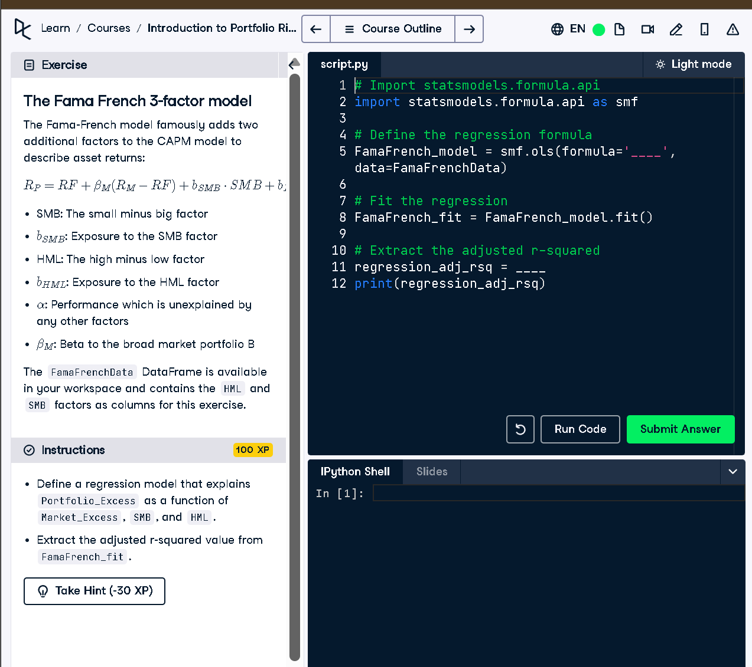

✅ Python Code Solution:
# Import statsmodels.formula.api
import statsmodels.formula.api as smf
# Define the regression formula
FamaFrench_model = smf.ols(formula='Portfolio_Excess ~ Market_Excess + SMB + HML', data=FamaFrenchData)
# Fit the regression
FamaFrench_fit = FamaFrench_model.fit()
# Extract the adjusted r-squared
regression_adj_rsq = FamaFrench_fit.rsquared_adj
print(regression_adj_rsq)

💡 50-Word Explanation:
This code fits the Fama-French 3-factor model, which explains stock returns using market excess return, SMB (small minus big), and HML (high minus low) factors. It uses linear regression to estimate the model and then extracts the adjusted R-squared to evaluate how well the model explains the data, considering complexity.

